Project Report

|  |  |
| --- | --- |
| Project Title | Problem Manage a Server Outage Scenario & an Issue & Change Request Management System |
| Qualification Name (NICF) | Advanced Certificate in Software Applications (Development and Deployment) |
| Product Name | NICF-Capstone Project using Java |
| Module Name (NICF) | NICF-Capstone Project using Java |

|  |  |  |  |
| --- | --- | --- | --- |
| Student name | | Assessor name | |
| Joshua Ho Gwok Hin | |  | |
| Date issued | Completion date | | Submitted on |
| 11 April 2022 | 18 May 2022 | | 18 May 2022 |
|  | |  | |
| Project title | Problem Manage a Server Outrage Scenario & an issue & Change Request Management System | | |

|  |
| --- |
| Learner declaration |
| I certify that the work submitted for this assignment is my own and research sources are fully acknowledged.  Student signature: Date: May 2022 |

Content – Project Management Report

1. Project background
2. Project Objectives
3. Project Requirement Specifications
4. Task 1 – Principles of Problem Management
5. Task 2 – Tools, processes & technologies
6. Task 3 - Investigation & Diagnosis
7. Task 4 – Severity, Frequency &/or Potential Implications
8. Task 5 – Solution to Implement for addressing problem
9. Task 6 – Documenting System
10. Task 7 – Best Practices & Industry Standards

# Project background

The scope of the project in this modules is to do **Problem Management throughout the SDLC** of the community portal commissioned by “ABC Jobs Pte ltd”. ABC Jobs Community Portal is a web application that is conceptually similar to Linkedin.com where:

1. Users will be able to register in the portal using the Registration Page.

2. Users of the portal can search for other users using various parameters such as First Name, Last Name, Company Name, City & Country.

3. Users will be able to view the Public Profile of users after searching them. The portal allow users to login, request for forgotten password and Update their profile information, and etc.

Problems are expected to arise during and after the SDLC of the Web Application. This project focus on ways to help manage these problems along the way,

# Project Objectives

The Project Objectives is to understand and deliver Problem management with the help of the following topics:

1. Principles of problem management throughout its lifecycle

2. Managing the lifecycle of a wide range of problems

3. Problem Identification, Investigation, Analysis, Resolve and Review

4. Technologies and processes to enable automated detection of incidents or problems

5. Root Cause Analysis (RCA) to identify, track, and resolve recurring incidents permanently

6. Problem prioritization, Sizing Techniques, Methodologies and Parameters

7. Documentation and tracking of problems encountered and resolved.

# Project Requirement Specifications

In this project, we will … The outcomes and deliverables are as follows:

Explain principles of problem management across its lifecycle.

Use various tools, process and technologies to facilitate problem identification, investigation, analysis & resolution

Explain various steps to investigate & diagnose problems.

Prioritize & Categorize change requests.

Prepare a solution to address the root cause of the problem.

Document & Monitor the problems

Explain best practices in documenting problems

Project Technical Environment:

This project consist of 2 documents:

ACWD_Project_Management_Report_Joshua.docx, and

ACWD_PM_Presentation_Joshua.pptx

Tools & platform used:

MS Word

MS PowerPoint

Draw.io

**MS Word MS PowerPoint**

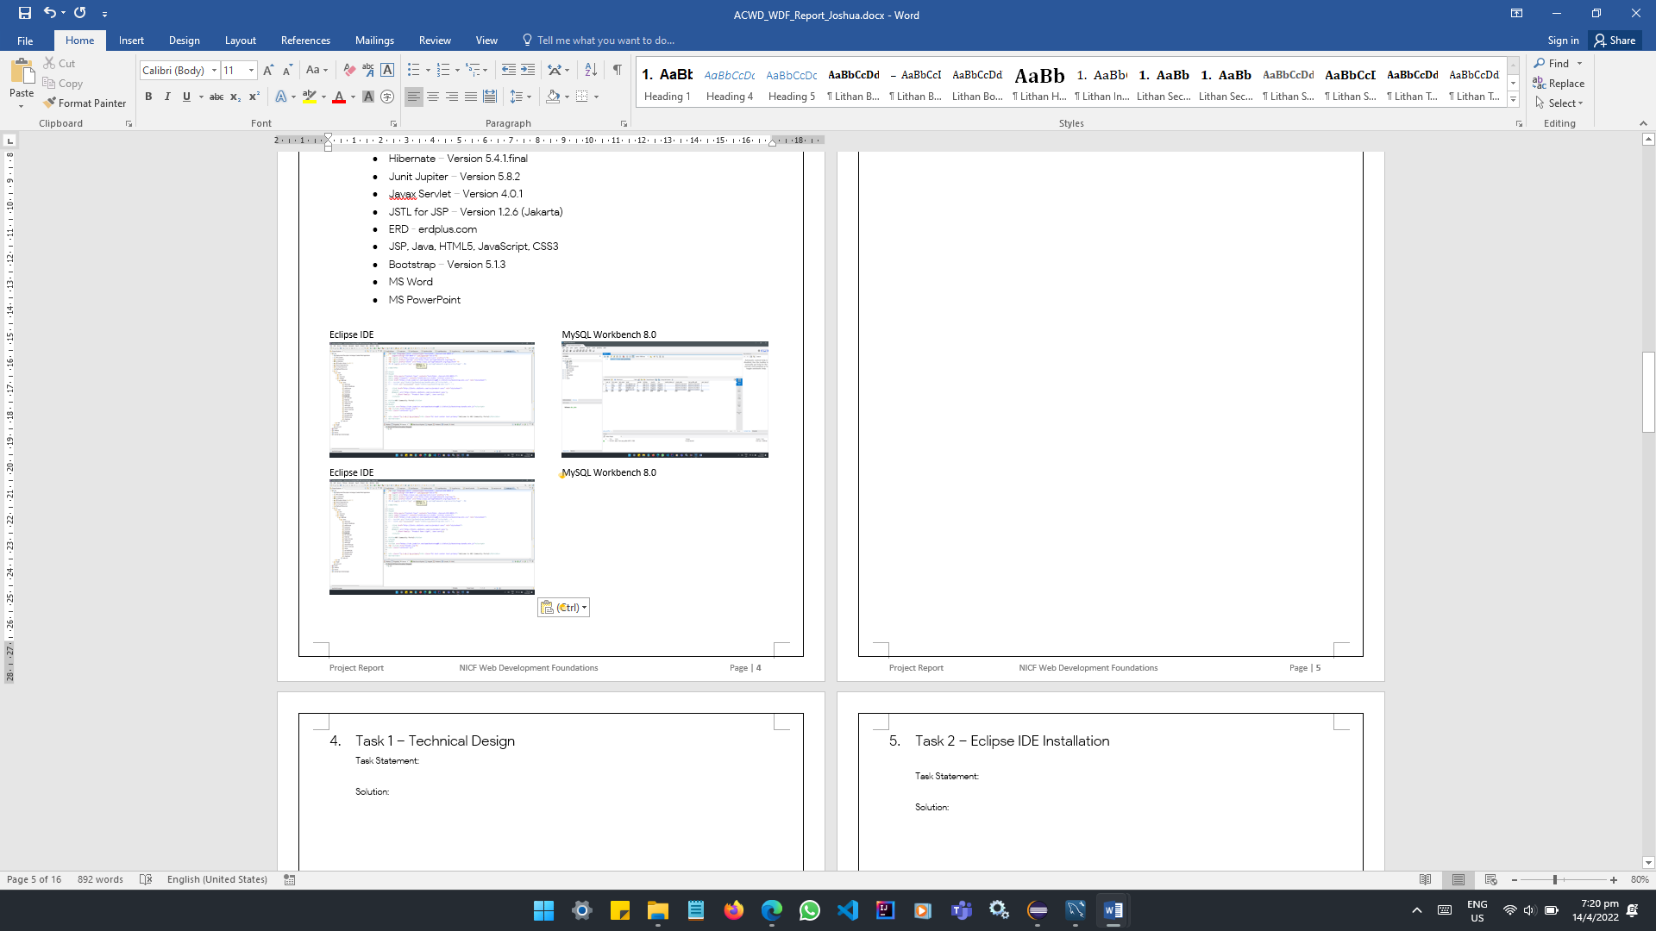 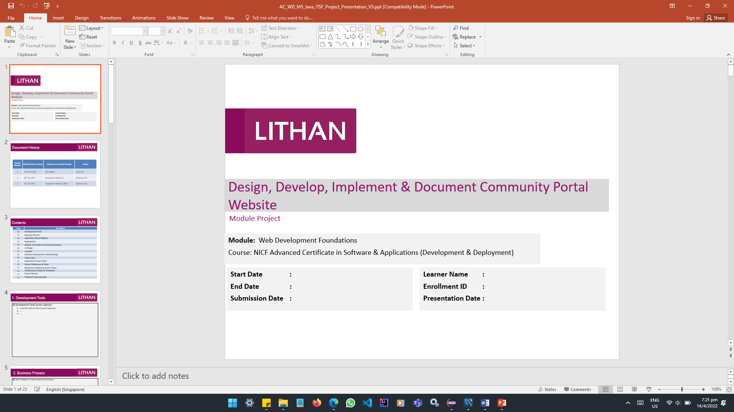

**Draw.io**

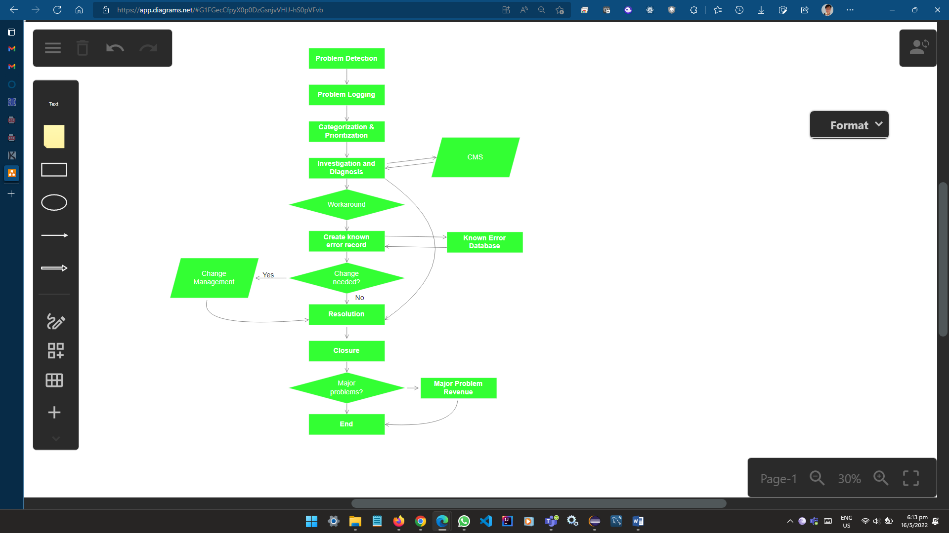

# Task 1 – Principles of Problem Management

Briefly explain principles of Problem management across its lifecycle,

What is a Problem?

A problem is a reported incident of a service failure. It requires an expert analysis to find the underlying root cause.

Problem Management

Problem management is the process of identifying and managing the causes of incidents on an IT service. It is a set of processes and activities responsible for managing the lifecycle of all problems that could happen. The goal is to prevent problems and their resulting incidents form happening/reoccurring. The Lifecycle starts when a problem is created and ends when the problem is resolved. Identification of the stages of diagnosis and remediation are considered to be a part of this lifecycle.

How Problem Management manages problem?

Problem Management is both a transactional process of managing the lifecycle of an individual problem and the portfolio management process of making decisions. These decisions consist of what problems should be addressed, the resources applied to them and the risks that problems present to the organization. It also includes the activities required to diagnose the root cause of incidents and determining the appropriate resolution steps that should be taken.

Scope of Problem Management:

Problem detection

Problem logging

Problem categorization

Problem Prioritization

Problem investigation and diagnosis

Create a known error record

Problem resolution and closure

Major problem review

Problem Management Workflow:

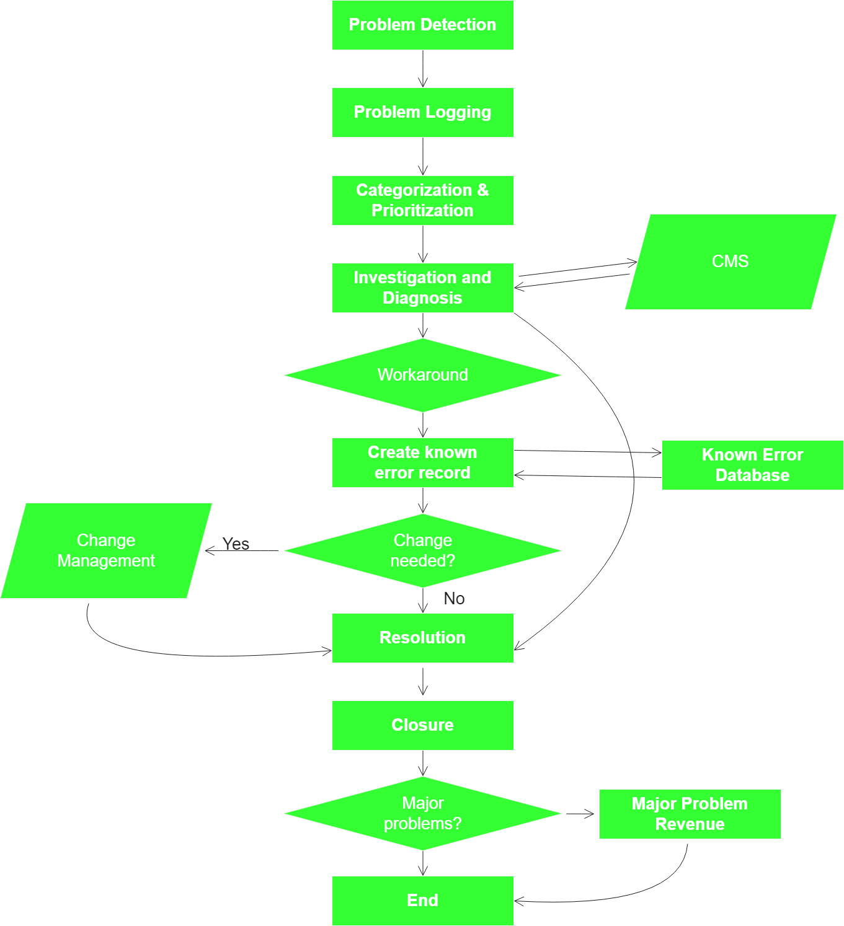

Problem Example: HTTP STATUS 404 – Not Found (Reactive)

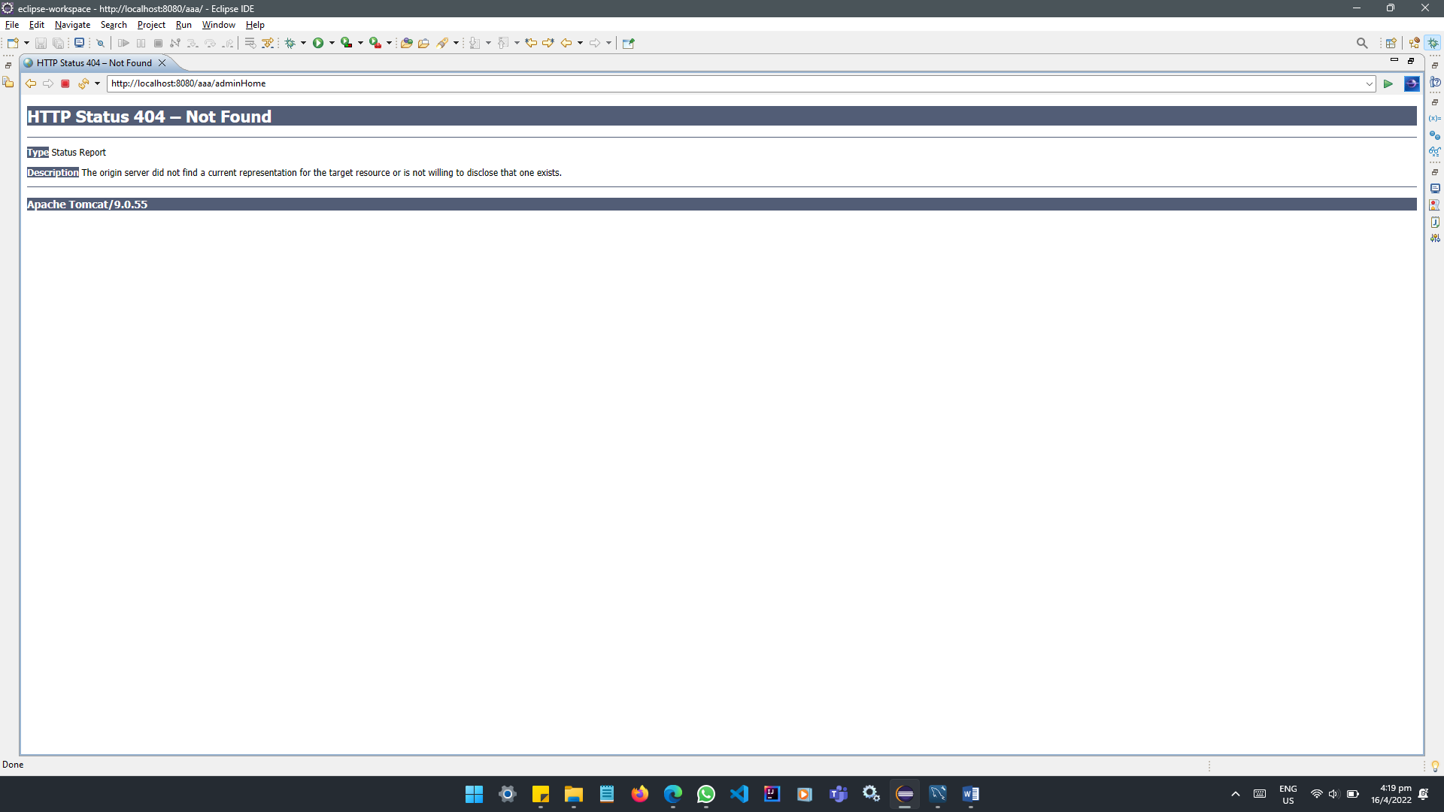

Steps:

1. Problem Identification

Problem identified and reported as follow:

Error occurs when “Next” button is clicked.

1. Log the problem

|  |  |  |  |  |  |
| --- | --- | --- | --- | --- | --- |
| Case No. | Date | Time | Problem | Error Msg/Code | Attachment |
| E01 | 10/05/22 | 10:00 | Unable to proceed after clicking “Next” button from the following url: http://8080.aaa/list.jsp | 404 – Not Found | Nil |

1. Problem investigation and diagnosis

Identified that the missing mapping in relation to the button appearing on list.jsp line no.56.

<a href=”next”>Next</a>

There is no matching mapping for “/next” in any controllers.

1. Problem resolution and closure

Added mapping for “/next” in line 38 in ExampleController.java

@GetMapping(”/next”)

public String next() {

return “next”;

}

|  |  |  |  |  |  |  |
| --- | --- | --- | --- | --- | --- | --- |
| Case No. | Date | Time | Problem | Error Msg/Code | Attachment | Status |
| E01 | 10/05/22 | 10:00 | Unable to proceed after clicking “Next” button from the following url: http://8080.aaa/list.jsp | 404 – Not Found | Nil | Problem Fixed.  Case closed |

# Task 2 – Tools, processes & technologies

Explain briefly various tools & technologies to facilitate problem identification, investigation, analysis & resolution.

Problem Management Process

1. Detect the Problem (Proactive/ Reactive)

A problem can be proactive or reactive. Proactive is often an evaluation of incident patterns or continual service improvement processes.

Both proactive and reactive leads to logging a problem ticket/escalated to relevant department.

1. Log the problem

Logging of problem should include details like time and date of occurrence, related incident(s), symptoms, the previous troubleshooting steps and the problem category.

1. Categorize the problem

Categorizing the problem allows the service desk to sort and model incidents that occur regularly, automatic assignment of prioritization and the ability to gather and report on service desk data.

Problems are prioritized based on how a problem impact the business. Prioritizing the problem allows an organization to utilize investigative resources effectively. High priority problem usually means that there is an urgency to address the issue.

1. Problem Analysis

Problem analysis involves investigation of the possible causes. High-priority issues should always be addressed first. While a problem can take from an hour to months to resolved, a workaround should always be indicated. Workarounds are temporary measures that help to enable the service desk to restore services to users.

1. Problem Solutions

Problems should be resolved whenever possible. Resolution resolves the underlying causes and prevents recurrences.

1. Close the problem

Closing the problem only occur after the problem has been raised, categorized, prioritized, identified, diagnosed and resolved. Many organizations stop at this step. However, reviewing the problem should follow after closing the problem.

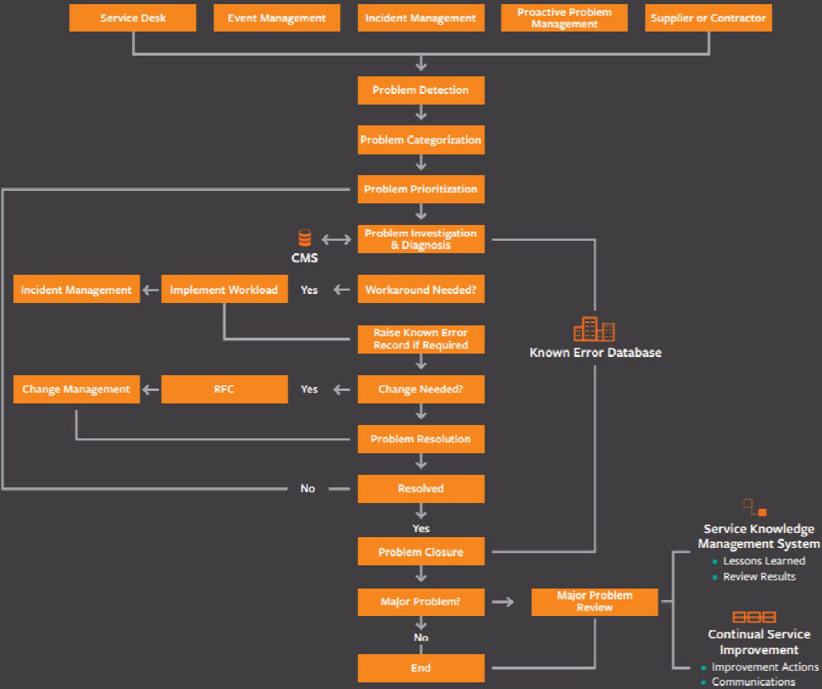

Problem Management Tools

1. Issue Identification and Tracking Document
2. Known Error Database (KEDB)
3. HP OpenView ServiceCenter

Issue Identification and Tracking Document

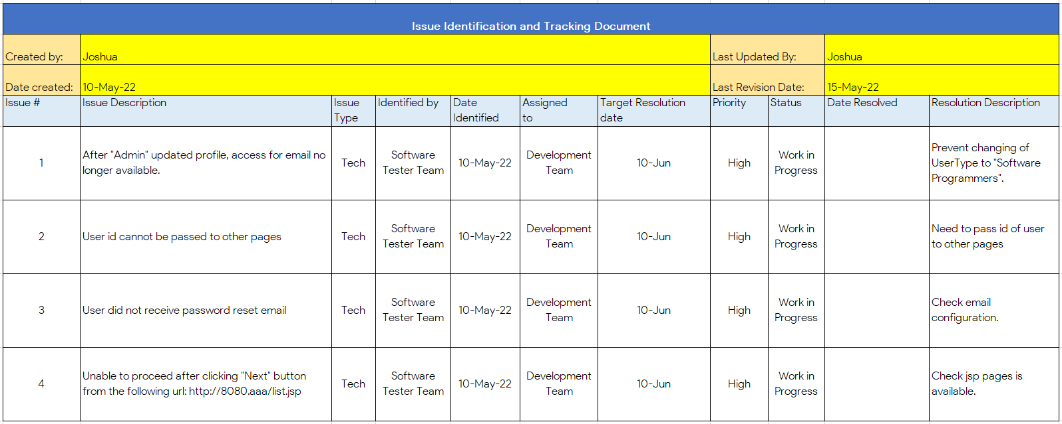

Known Error Database

|  |  |  |  |  |  |  |
| --- | --- | --- | --- | --- | --- | --- |
| Case No. | Date | Time | Problem | Error Msg/Code | Attachment | Status |
| E01 | 10/05/22 | 10:00 | Unable to proceed after clicking “Next” button from the following url: http://8080.aaa/list.jsp | 404 – Not Found | Nil | Problem Fixed.  Case closed |

HP OpenView ServiceCenter

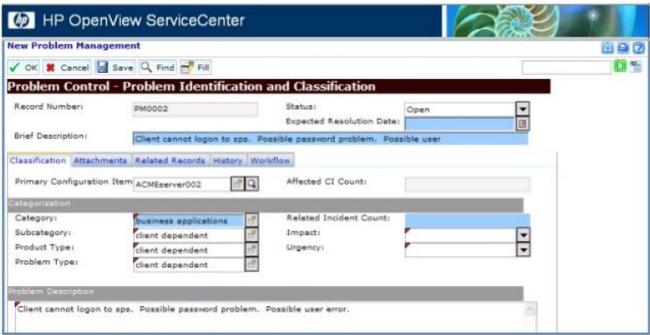

# Task 3 - Investigation & diagnosis

Explain briefly various steps you will take to investigate & diagnose problems.

Steps of Fish bone RCA:

1. Define problem statement

A problem statement is a description of an issue that requires urgent attention. Explains why the problem matters and what would happen to the project if the issue is not fixed on time. It helps team leaders to understand the current issues affecting the project and build on that to find practical solutions.

1. Add cause categories as fish bones

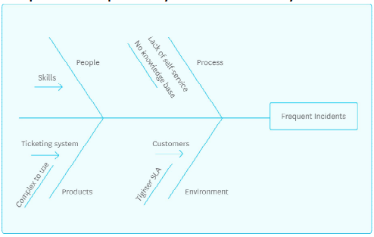

1. Use traditional brainstorming techniques to fill in possible reasons

Problems with Database possible causes:

Connection – JDBC, DB Server, and etc.

SQL Statement – Repositories, outdated queries, and etc.

1. Classify and prioritizing primary and secondary causes as trunks

# Task 4 – Severity, Frequency or Potential Implications

Briefly explain how you will prioritize, categorize incident & change requests for the application according to their severity, frequency or potential implication.

|  |  |  |  |
| --- | --- | --- | --- |
| Handling Tier | Tier 1 | Tier 2 | Tier 3 |
| Priority | Low | Medium | High |
| Impact (Generally) | user | other users | business and other users |
| Description | Basic Issues that can be fixed with general computer troubleshooting and does not impact business or other users. | Issues that have some impact on the user but not on the business as a whole, medium priority that requires more immediate response and higher level of access or training than tier-one incidents. | High priority incidents that affect the entire organization and many users. Often, these incidents fall into Major Incident Response (MIR) process. |

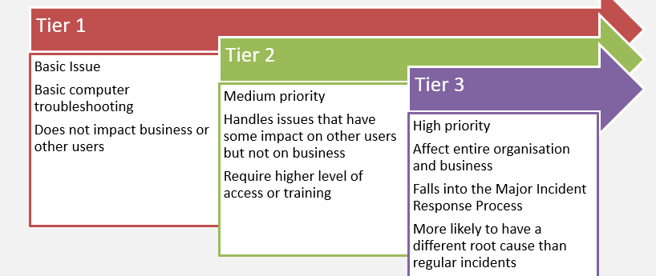

Categorize the problem

Categorizing the problem allows the service desk to sort and model incidents that occur regularly, automatic assignment of prioritization and the ability to gather and report on service desk data.

Problems are prioritized based on how a problem impact the business. Prioritizing the problem allows an organization to utilize investigative resources effectively. High priority problem usually means that there is an urgency to address the issue.

# Task 5 – Solution to implement to address problem(s)

Explain about the solution you will implement to address the root cause of the problem and avoid their reoccurrence.

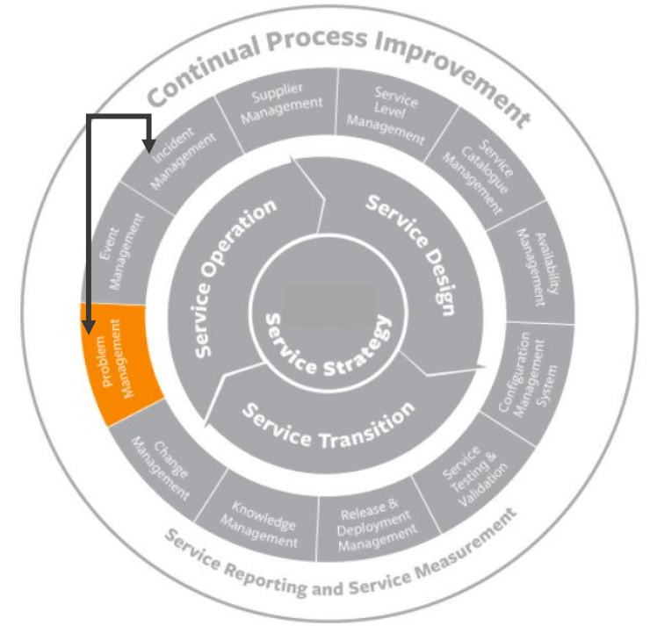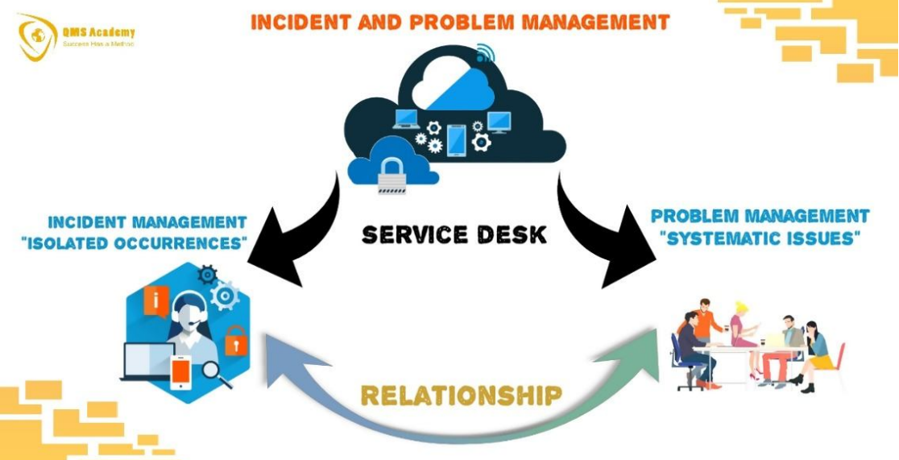

Problem management eliminates the cause of failed services with the following steps:

1. Diagnose the problem and validate any workarounds.
2. Once identified, record as a “known error” in KEDB
3. Initiate a change request to be evaluated by the change management process.

Proactive Problem management deals with identifying and solving problems before any incidents have occurred. This activity is associated with Continual Service Improvement (CSI).

Implement Problem management with planning in tools, system and training.

**System and tools**: Known Error Database as a tool for the Service Desk

**Training:** Problem Identification, Investigation, Analysis, Resolve and Review

Implement a Known Error Database into the Web Application for “Admin” users. The purpose of this database is to record known issues and workarounds. As the first interaction of the problem is at the Service Desk, having access to KEDB makes it easier to do Problem Controls and Error Controls.

# Task 6 – Documenting system

Briefly explain how will you document the problems encountered and monitor them.

Recommend the systems suitable to manage the problem:

We have 2 documentation/records for our Problem Management Systems. They are the

1. Issue Identification and Tracking Document, and
2. Known Error Database

The first is filed by the Service Desk and CSI team. It will then be reflected into the Known Error Database with a status to monitor the progress. Known Error Database is available to “Admin” users in the Web Application.

Keeping documentation and tracking of problems encountered and resolved as best practices and industry standards in documentation related to problem management.

**Known Error Database** (KEDB) is a database that describes all of the known issues within the overall systems. I contains information of situations in which these issues appear, and when possible. It offers workaround that will get the user around the problem and back to productive work. This database also become part of the overall Problem Management Database.

A Known Error Database contains information like the **status, error description, root cause, screenshots and workarounds**. These information helps promote productivity when others may plan and/or make quick decisions to deal with the same problem either with workarounds or try other alternatives.

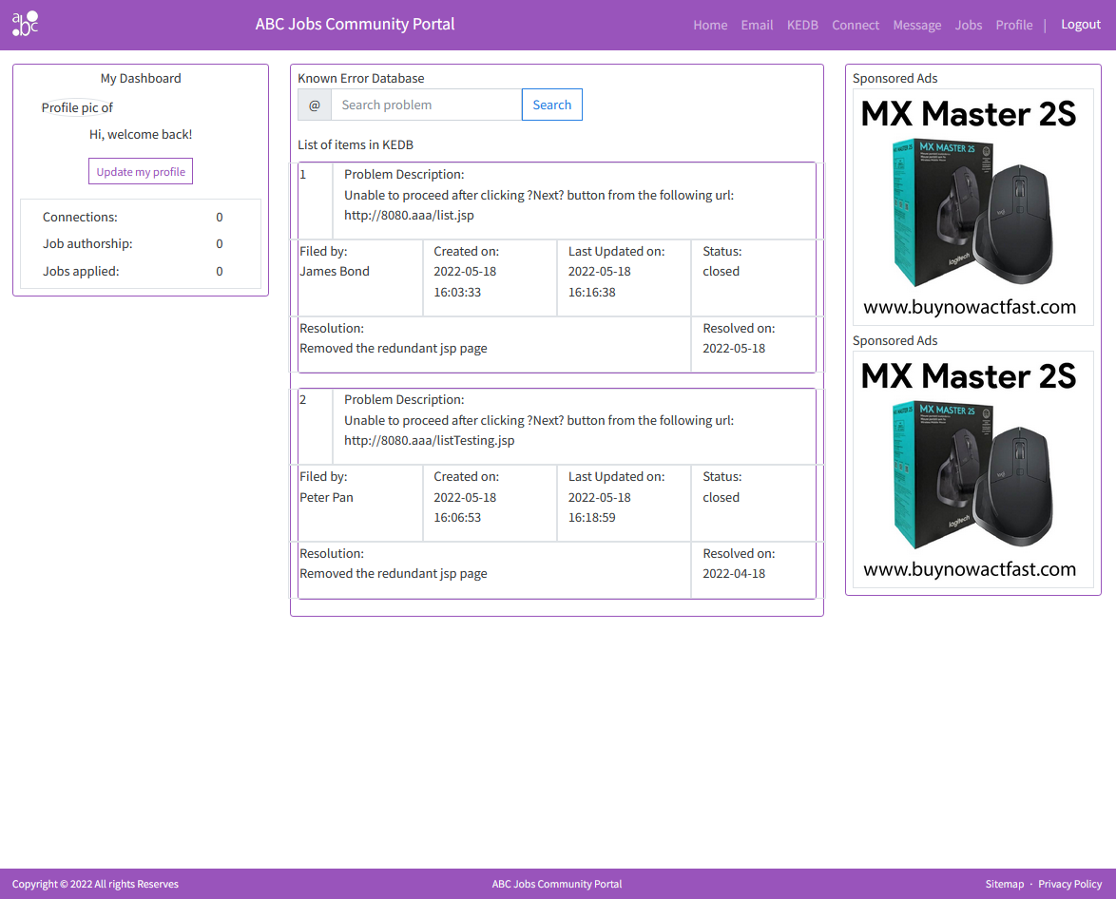

# Task 7 – Best Practices & Industry Standards

Information Technology Infrastructure Library (ITIL), is a set of detailed practices for IT activities. Here are the three of the practices/approaches from the ITIL 4 which may a workplace may adopt as best practice.

1. **The 7 ITIL Guiding Principles**
   1. Focus on value
   2. Start where you are
   3. Progress iteratively with feedback
   4. Collaborate and promote visibility
   5. Thank and work holistically
   6. Keep it simple and practical
   7. Optimize and automate

This principle focuses primarily on simplicity and the prevention of complications. Using the minimum number of steps to deliver the desired outcome and not over-processing. It is better to apply general or standardized processes in exception handling.

1. **Continual Improvement**

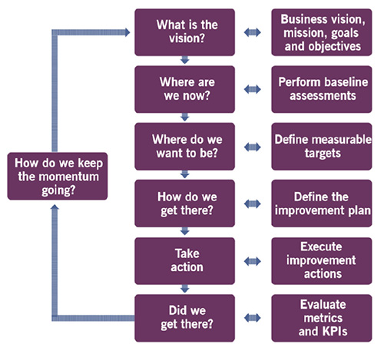

The improvement should support the organizations’ goals and objectives, have a clear starting point. Set Key Performance Indicators (KPI) and the objectives of the improvement initiative. Execute the plan, check and confirm the progress. If the initiative is a success, use it to build support and momentum for the next improvement initiatives.

1. **ITIL Service Value Chain**

The ITIL SVC is an operating model that enables the delivery of services utilizing 6 key activities. These activities are:

1. Plan – Focuses on strategy, practitioners develop an understanding of what a service needs to deliver.
2. Improve – Gradual and continuous improvement of all activities.
3. Engage – Provide a service level by finding out what stakeholders needs are and guarantee complete transparency. These needs turn to become tangible design points.
4. Design and Transition – takes the expectations from previous state and make sure the service product satisfy it. Requirements are translated into Specifications.
5. Obtain/Build – Ensures service components meet required specs, effectively turns requirements into service components.
6. Deliver and Support – Focuses on deliverables of the services and products and Continual Service Improvement.

ITIL activities and practices are adopted in various ways in an organisation as best practices and/or industry standards.